LAB 3_solution

1. Keys in the table:

a. Product – PROD_ID: primary key; PROD_VENDOR: foreign key

b. Vendor – VEND_ID: primary key

1. Create table

CREATE TABLE Vendor (

VEND_ID VARCHAR (05) NOT NULL,

VEND_NAME VARCHAR (70) NOT NULL,

VEND_ST VARCHAR (10) NOT NULL

CONSTRAINT VendorPK PRIMARY KEY (VEND_ID)

);

CREATE TABLE Product (

PROD_ID VARCHAR (10) NOT NULL,

PROD_NAME VARCHAR (50) NOT NULL,

PROD_PRICE INT NOT NULL,

PROD_VENDOR VARCHAR (05) NOT NULL,

CONSTRAINT ProductPK PRIMARY KEY (PROD_ID),

CONSTRAINT ProductFK FOREIGN KEY (PROD_VENDOR) REFERENCES Vendor (VEND_ID)

);

1. Insert data

INSERT INTO Product (PROD_ID, PROD_NAME, PROD_PRICE, PROD_VENDOR)

VALUES

1. Query all rows and all columns in the Product table in order of increasing product prices.
2. 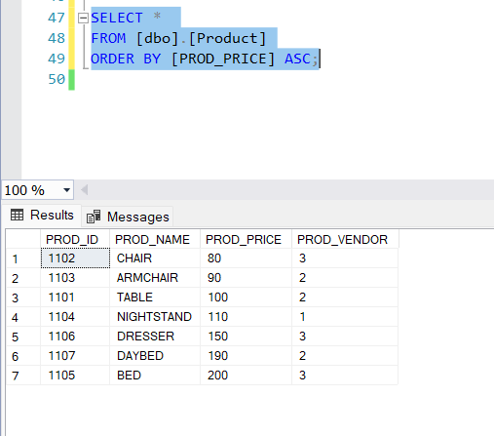
3. Find all products that are cheaper than or equal to $150.

SELECT *

FROM [dbo].[Product]

WHERE [PROD_PRICE] <= 150;

1. Find all products that are chair types.

SELECT *

FROM [dbo].[Product]

WHERE [PROD_NAME] LIKE '%CHAIR%';

1. The company plans to raise the prices of all products by 20%. Write a query that returns the product name, the old product price, and the new product price.
2. A screenshot of a computer

   AI-generated content may be incorrect.